City of Stanton Economic Development & Martin County Chamber of Commerce

August 2017

Dates to know

* 7th- Stanton High School Football practice begins-7 A.m. to noon
* 18th- Movies in the park-The Sandlot
* 21st- First Day of School-Stanton/Solar Eclipse
* 28th-First day of school-Grady

Movies in the Park

Days, Stallings & Herm, P.C. CPA’s, Tunnell Insurance Agency, Wes-Tex Telephone Coop and Wheeler Motor Company! A special thank you to the City of Stanton for allowing us to paint a “screen” on a building, and for helping paint and providing supplies, and to Tractor Supply for donating the paint. We can’t do what we do without all of you!

host Movies in the Park in the future. The Martin County Chamber of Commerce would like to thank our members and sponsors who helped make this community event a reality: First National Bank, Lynn W. Atchison, CPA, EJ’s Cotton Pickin’ Dive, M&M Disposal, Martin County Hospital District, Old Sorehead Trade

Final round! The Chamber of Commerce is excited to announce the next showing for Movies in the Park! Friday, August 18, 2017 will feature The Sandlot at City Park! Concessions will open at 8:00 p.m. and the movie will begin at 9:00 p.m. Don’t forget to bring lawn chairs or blankets for seating. Please clean-up any mess as so we may

Passion will keep you going when the going gets tough-David Copperfield

Back to School

School will be back in session at the end of August. Time to get all the school clothes, shoes and supplies! Tax free weekend is August 11th - 13th. Stanton I.S.D. is welcoming new staff members: Robyna Anderson,

Smith, Trina Springer and Louann Sullivan. Grady is welcoming new faculty members: Minde Ivy and Jym Dennison. Thank you to our Martin County schools for taking great care of our children!

Aaron Bowles, Shante Ezell, Jamie Mitchell, Ricky Fleckenstein, Winette Brown, Coby Hogan, Kelly Inman, George May, Dennis Millner, Jennifer Morgan, Amber Noland, Linsey Rivas, Kolten Self, Pamela

Shop Stanton First!

City of Stanton Economic Development & Martin County Chamber of Commerce

August 2017

Old Settlers

The Best of Show winner for the Old-Fashioned County Fair went to Youth: Tripp Wells with a knife sheath and Adult: Matt Hale with a table. The Convent, Connell House and Museum opened for the event. After the catered meal by the Baker’s and the closing ceremony, the evening was wrapped up with the Chamber of Commerce hosting the Old Settlers Dance with Mike Payne Band handling the entertainment. Thank you, First National Bank for sponsoring the dance!

This year marked the 84th Old Settlers Event. The day kicked-off with the parade. Winners for Reunion Floats were: 1st-Class of 1967, 2nd-Class of 1972 and 3rd-Class of 1997. Best themed floats were: 1st-Heavenly Daycare, 2nd-KB Signs, 3rd-Stanton Middle School Cheerleaders. Top Family/Organization floats were: 1st-Sanchez Family, 2nd-Stanton High School Cheerleaders, 3rd-Gonzales Family 50th Wedding Anniversary. The family honored this year was M.L. “Red” Reva Koonce.





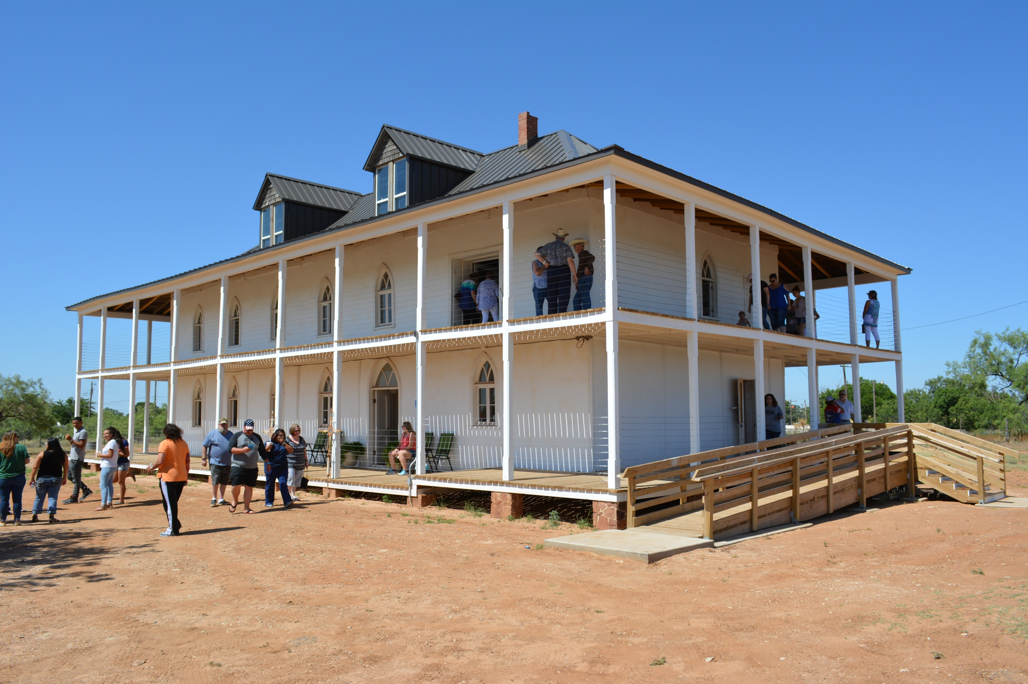

WesTex By: Kelley Pickens

**Westex is scheduling installation appointments for the new Fiber Optic services NOW. Please be aware that your current service will be discontinued if you**

**have not completed an updated agreement for the fiber transition. Service agreements are available online for existing** customers at [www.westex.coop/orderform](http://www.westex.coop/orderform). Existing and new

customers are welcome to call or come by today, to fill out your agreement. Call (432)756-3826 or come by 1500 W. Business 20 in Stanton.



|  |  |  |  |  |  |  |
| --- | --- | --- | --- | --- | --- | --- |
| August | | | | | | |
| S | M | T | W | T | F | S |
|  |  | 1 | 2 | 3 | 4 | 5 |
| 6 | 7 | 8 | 9 | 10 | 11 | 12 |
| 13 | 14 | 15 | 16 | 17 | 18  Movies in the Park | 19 |
| 20 | 21  First Day of School-Stanton | 22 | 23 | 24 | 25 | 26 |
| 27 | 28  First Day of School-Grady | 29 | 30 | 31 |  |  |
|  |  |  |  |  |  |  |

Cheap & Easy Chicken Spaghetti

Ingredients:

* 1 rotisserie chicken (deboned)
* 1 package of spaghetti
* 1 lb. Velveeta cheese
* 1 can cream of mushroom
* 1 can Rotel
* Shredded cheese
* ½ teaspoon garlic powder
* Salt and Pepper to taste

Directions:

1. Bring pot of water to boil and add pasta.
2. While the pasta is cooking, debone chicken and cut Velveeta block into cubes.
3. Strain cooked pasta, add chicken, Velveeta, cream of mushroom soup, garlic powder, salt and pepper.
4. Cook pasta mixture over medium low until cheese is melted and ingredients are incorporated.
5. Place pasta mixture into a pan, top with shredded cheese and bake at 375 degrees for 20 minutes.

**\*Shop Stanton First*Shop Stanton First *Shop Stanton First *Antiques on Main *Borrowed Recipes *City of Stanton *The Clothes Line *Community National Bank *Cornerstone Comp. Truck Sales *EJ’s Cotton Pickin’ Dive *Eiland & Associates, Inc. *Express Dry Cleaners *Farm Bureau Agent Paula Stiles-Altman *Farmer’s Cooperative Association *First National Bank *First United Methodist Church *Franklin & Son Inc. *Home Hospice *Jeff Martin Auctioneers *Lynn W. Atchison, CPA *M&M Disposal & M&M Meter Services Inc. *Martin Center RV Park *Martin County AgriLife Extension *Martin County Appraisal District *Martin County Convent *Martin County Hospital District *Martin County Messenger *Midland Texas Services LLC. *Mimi’s Britches & Bows *Old Sorehead Trade Days *Pates Hardware, Inc. *Permian Basin Underground Water Conservation District *Redneck Metal Buildings LLC. *Sharyland Utilities *St. Joseph’s Catholic Church *S.D. Baker Construction Co., Inc/Sam’s Surplus *Stallings & Herm CPA’s *Stanton Car Wash *Stanton i.s.d *Stewart Title *Stone Ranch *Tarzan Coop Gin *Tractor Supply Store #1914 *Tunnell Insurance Agency *WesTex Telephone Cooperative, Inc. *Wheeler Motor Co., Inc. *White Motor Company *Shop Stanton First*Shop Stanton First*Shop Stanton First*Shop Stanton**